Bungalow At Gondia.

1. Project Information
- Project Name: Private Bungalow
- Location: Gondia ( Maharashtra)
- Plot Area: 880 sq.mt.
- Built-up Area: 11000 sq.ft.
- Project Type: Residential
- Status: On going

Project Overview
The bungalow at Gondia is conceived as a contemporary G+1 residence organized around light, landscape and connected family living. Its asymmetrical C-shaped plan consists of two wings of unequal length that embrace a central courtyard, with the open side extending toward the larger garden.
The courtyard forms the social and visual heart of the house, bringing daylight, ventilation and greenery into the surrounding spaces. A skylit atrium positioned between the living and dining areas creates a second internal focus, introducing natural light into the centre while establishing a gentle transition between the principal family spaces.
The ground floor accommodates the primary living and family areas with a strong connection to the courtyard and garden. The first floor combines private spaces with lifestyle amenities, including a home theatre, gym and jacuzzi, creating a dedicated level for recreation, wellness and relaxation.
Strong geometric frames, rounded openings, vertical screens and warm timber finishes give the bungalow a refined contemporary identity. Deep recesses and shaded outdoor spaces further respond to Gondia’s warm climate.

Concept — The Open Courtyard Embrace
The concept, “The Open Courtyard Embrace,” is derived from the bungalow’s asymmetrical C-shaped form. The longer and shorter wings partially enclose the central landscape, creating privacy and protection while remaining open toward the garden.
The design is structured around two complementary sources of light and nature: the one-side-open courtyard and the skylit atrium. The courtyard supports outdoor gathering and connects the house with the landscape, while the atrium brings daylight into the living–dining core.
The G+1 organization establishes a clear lifestyle hierarchy: connected family living and garden interaction at ground level, with recreation and wellness amenities above. Together, the courtyard, atrium and upper-level amenities create a residence that balances openness, privacy, comfort and contemporary luxury.

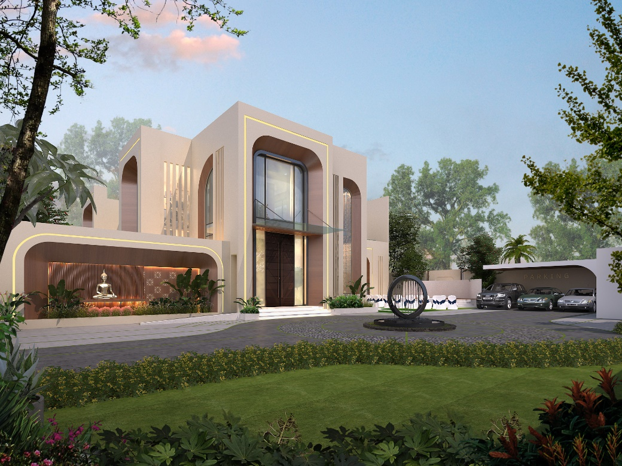
Image 1
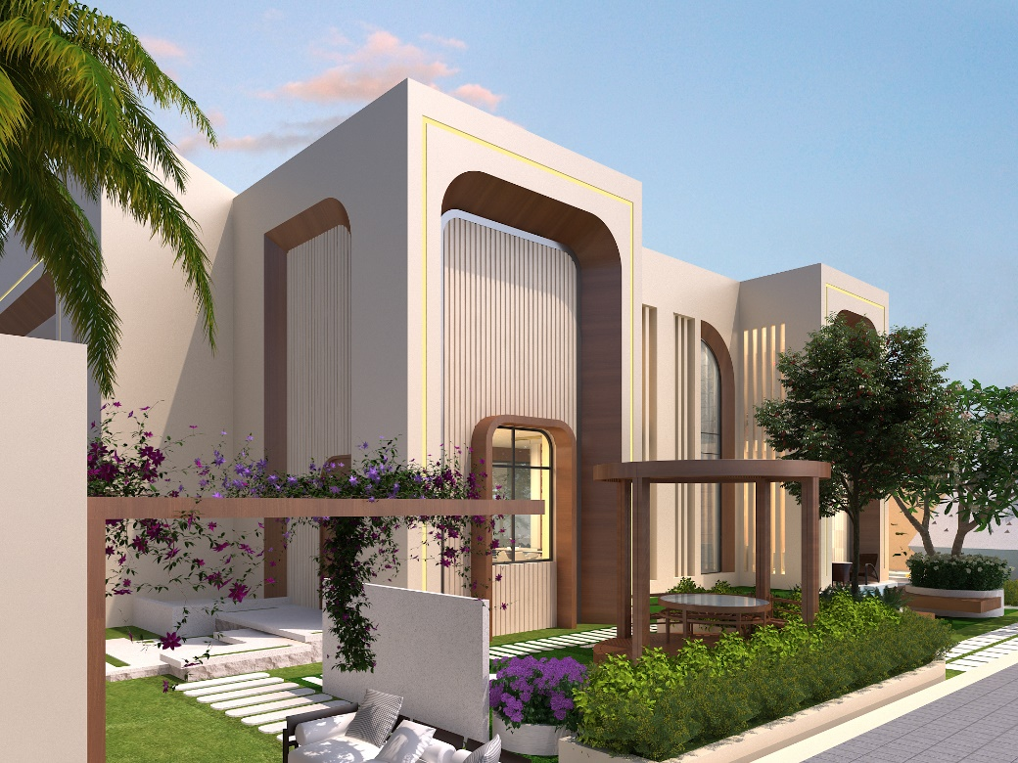
Image 2

